AutoEmail – Clayton Utz AutoEMails
Tester: Tony Tasker
Date: 6th December 2016
Time: 16:00
PC/Server: TonyTasker-PC
Database: PwC_Oz_UnitTest
Works Summary: N/A
Works Order: N/A
Task: N/A
Notes: These tests were performed using Microsoft SQL Server Management Studio. Output to the Results and Messages Output Windows are used to determine the success of the tests. Also the receipt of emails.

Pre-Test Setup
No | Task | Tester | Pass | Notes
1 | In section CABS_AUTO_EMAIL_FUNCS_Trigger  Add DebugFlag=1  Ensure Enabled = 1 | TT
2 | In section CABS_AUTO_EMAIL_FUNCS_Trigger  Add DebugFlag=1  Ensure Enabled = 1 | TT

Post-Test Setup
No | Task | Tester | Pass | Notes
1 | Reverse any Config Changes in X CABS Config | TT

Tests

Update Email – AEFUPD – New Booking
No | Test | Tester | Pass | Notes
1 | Using the CABS Console created a new function to test with:  Using F423285 on the 13/12/2016 | TT |  | Must be in the future
2 | No Email was sent for a New Booking  SELECT * FROM vw_AEFLink  No record found | TT

Update Email – AEFUPD – Updated Booking
No | Test | Tester | Pass | Notes
1 | Using the CABS Console created a new function to test with:  Using F423285 on the 13/12/2016  Added 3 external visitors  Added text in the Purpose field  Changed Covers from 2 to 3  Then saved the changes | TT
2 | Checked the queue  select * from vw_AEFLink  1 Record for AEFUPD, F423285 | TT
3 | Process the AutoEmail  Run command the below command from MS SQL Server Management Studio  EXEC CABS_AUTO_EMAIL_FUNCS_SESS_CHECK | TT |  | Email delivered as per Figure 1

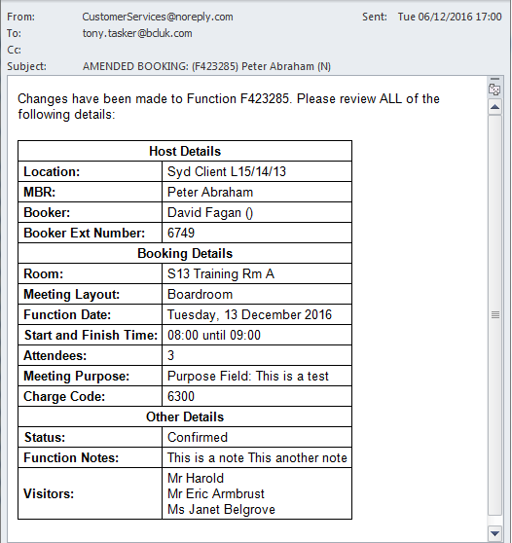
Figure 1 – Update Email

